The owner of this document Darren Cosgrave

Student number B00067349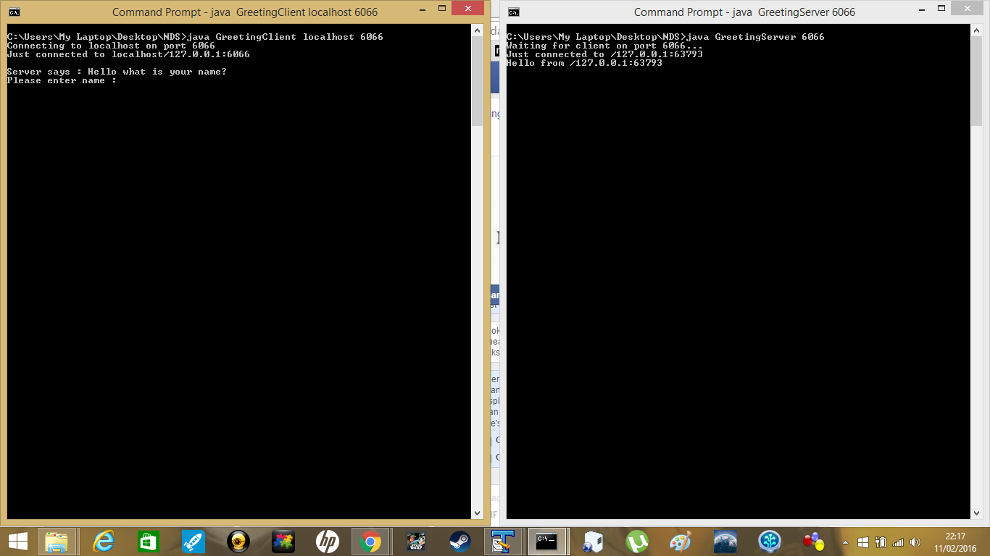

So as you can see the server on the right sends a question to the client on the left.

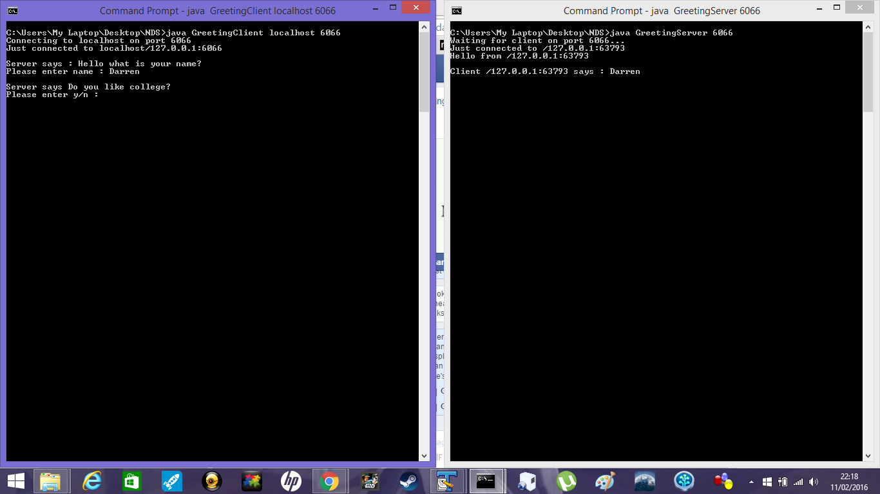

The client on the left types Darren for the question and the server prints out the client’s response.

Also as the server prints the response and it sends another question to the client.

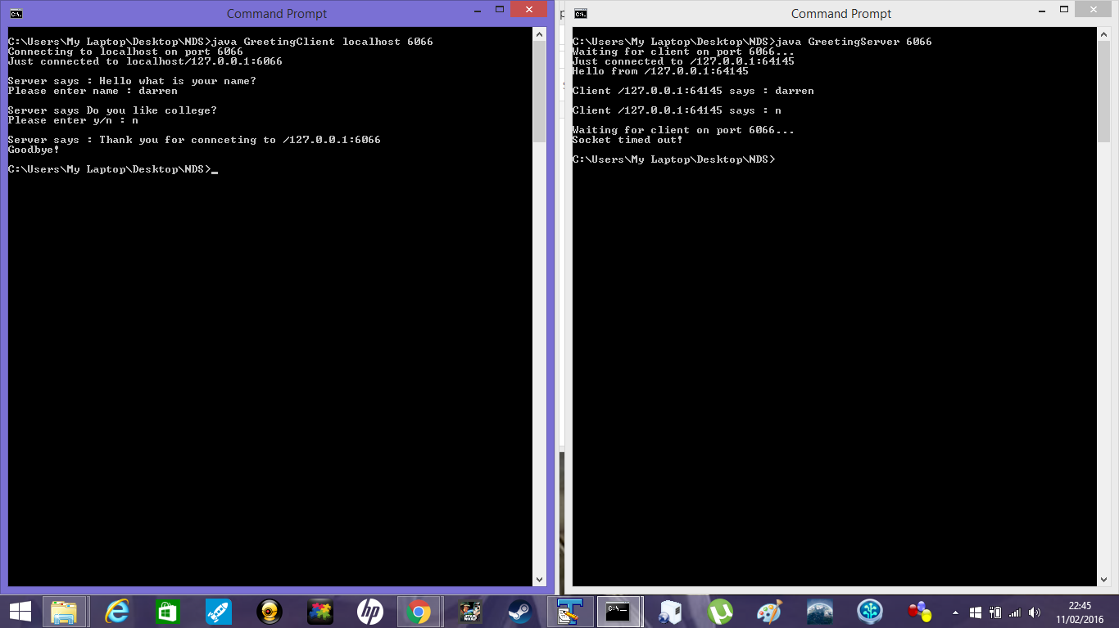

The client enters the response for the new question and is printed on the server side, then kills the connection to the client. It waits for a new client, if there is no response the socket times out.

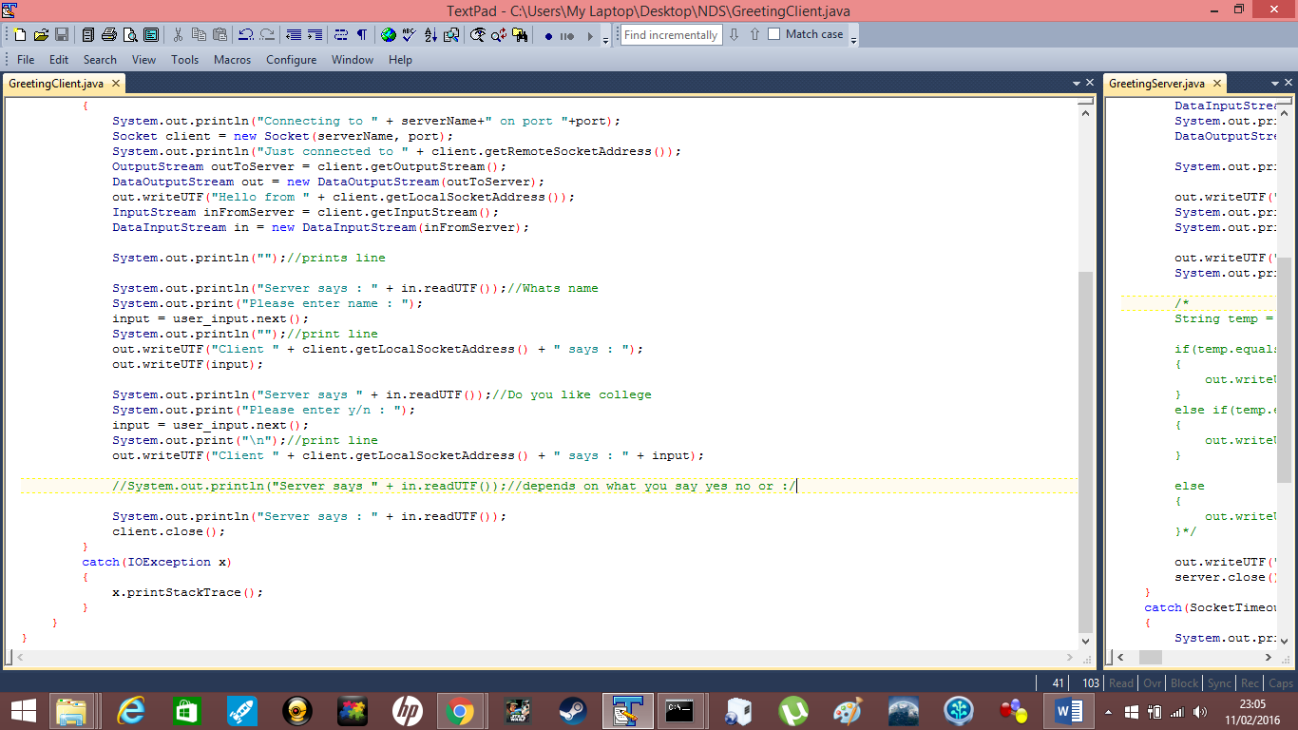

Client - Code used to achieve the above result on client side.

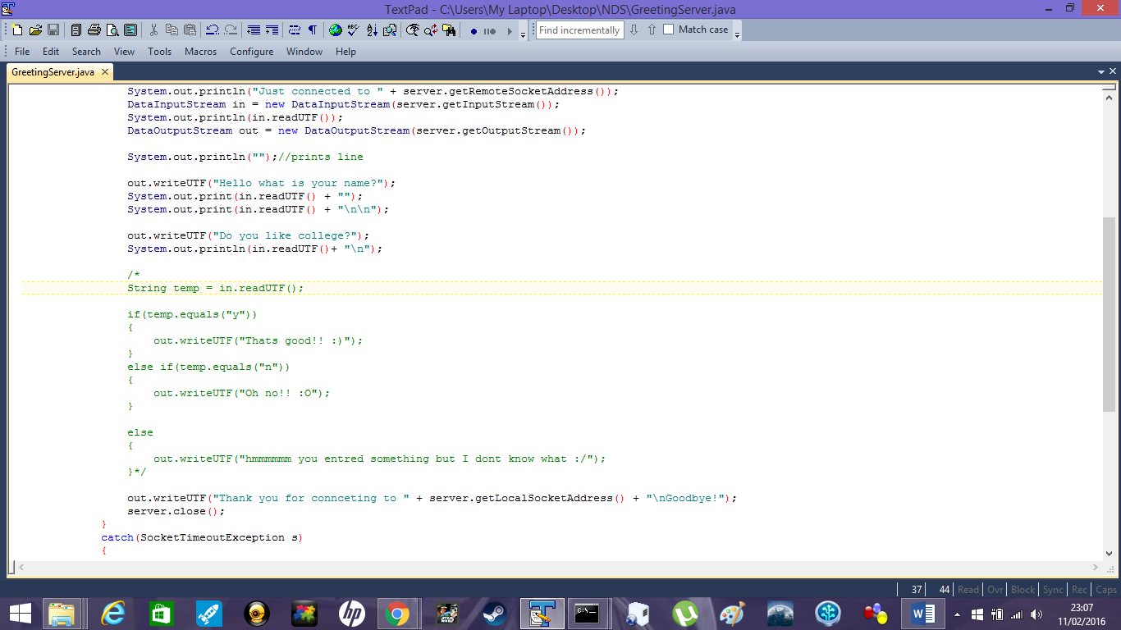

Server – code used to achieve the above result on server side.